Assign Roles to New Users Documentation
Only “Admin” or “Owner” roles can view the Statistics Dashboard.

- Find the “Statistics: *” pages on the Wix dashboard. The Statistics Dashboard is divided into three pages: Overview, Event, Volunteer. Click on “Statistics: Overview” to start.
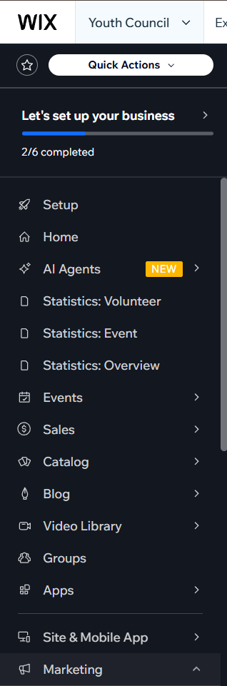
- Click between the tabs near the top of the page to switch between the different pages. Click on the year dropdown to filter stats by year, or keep it on “All years” for a combination of all years.
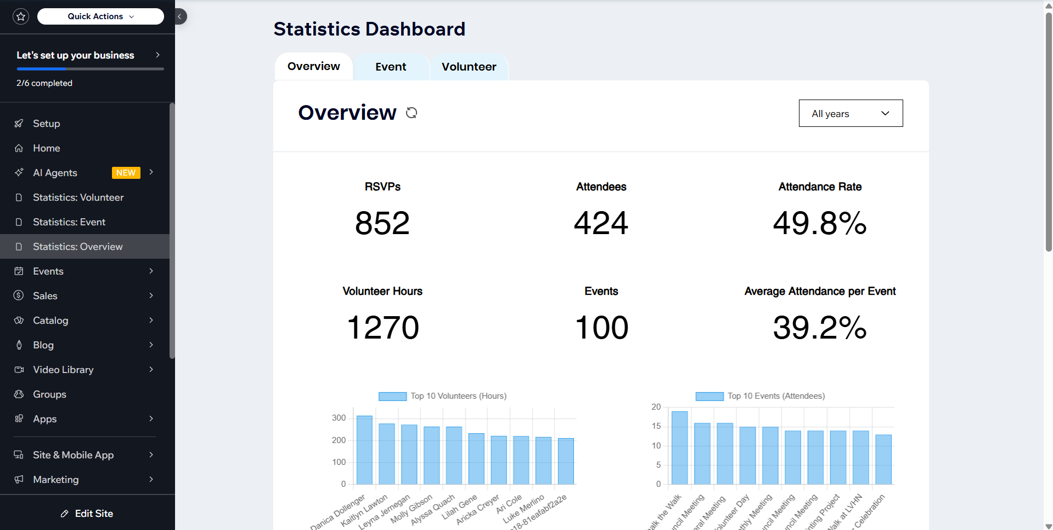
- On the Event and Volunteer page, you can pick a specific event or volunteer using the event dropdown or volunteer dropdown. You can use the year dropdown and the event name at the same time to find a specific event or volunteer if active for multiple years.
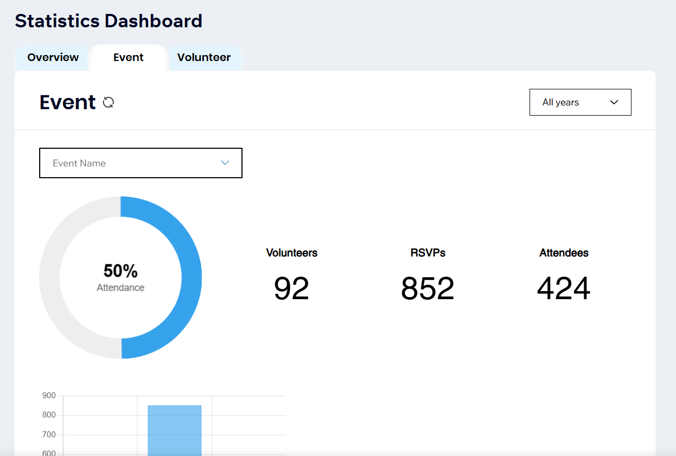

Definitions
Overview:
- RSVPs - Total amount of RSVPs/Registrations for this year
- Attendees - Total amount of check-ins for this year
- Attendance Rate - RSVPs divided by Attendees as a %
- Volunteer Hours - event duration * attendees (total amount of hours volunteered) for each event for this year
- Events - Total amount of published events
- Average Attendance per Event - The average of all events’ attendance rates
- Top 10 Volunteers - Top 10 volunteers based on hours volunteered
- Top 10 Events - Top 10 events based on amount of attendees
- Bottom 10 Volunteers - Bottom 10 volunteers based on hours volunteered
- Bottom 10 Events - Bottom 10 events based on amount of attendees
- Attendees (last 10 events) - The amount of attendees for the 10 most recent events this year
- Volunteers per Year - The amount of unique volunteers who have been checked-in to an event, year by year
Event:
- Attendance: RSVPs divided by Attendees as a %
- Volunteers: The amount of unique volunteers who have been checked-in to an event this year
- RSVPs - Total amount of RSVPs/Registrations for this year
- Drop offs - RSVPs minus Attendees
- Attendance vs Avg Attendance - Attendance compared to Average Attendance per Event for this year, with the difference in percentage to the right
- Rank - The rank of the event out of all other events in this year, based on attendees then RSVPs if attendees are tied
- Attendance vs Previous Year - If this event occurred the previous year, compares this year’s attendance rate to the previous year’s attendance rate, with the difference in percentage to the right
Volunteer:
- Events attended: Number of events this volunteer attended
- Hours volunteered: Total amount of hours volunteered
- Attended vs RSVPs: Number of Events attended compared to number of RSVPs, in a ratio
- Events attended per year: Number of events attended each year
- Events attended per month: Number of events attended each month for this year
- Volunteer rank: Rank out of all other volunteers based on Hours volunteered for this year

Notes to consider
- The statistics become less accurate the earlier the events are. For example, there are no recorded check-ins and fewer volunteers than actual for the year 2022.
- Opening the dashboard and switching between pages takes around ~5-15 seconds. I apologize for the slow loading.
- Volunteers who do not have their name recorded may have their database memberId shown instead.

